 | Bansilal Ramnath Agarwal Charitable Trust’s  Vishwakarma Institute of Information Technology  Department of  Artificial Intelligence and Data Science
Student Name: Sathe Onkar Abasaheb
Class: TY | Division: B |  | Roll No.: 372078
Semester: III |  | Academic Year: 2025-2026
Subject Name & Code: Cloud and DevOps
Assignment No: III
Title of Assignment: Deploy a Static Website on AWS – Host a website using Amazon S3
and configure public access.
Date of Performance: |  | Date of Submission:

Aim: To deploy a static website using AWS S3 service.

Objective: Deploy a Static Website on AWS – Host a website using Amazon S3 and configure public access.

Materials Required: Computer with internet connection and having a AWS account.

Procedure:
About AWS:
AWS (Amazon Web Services) is a comprehensive and widely-used cloud computing platform developed by Amazon. It offers a range of services such as computing power, storage, databases, networking, machine learning, and more— all delivered over the internet (the cloud).
With AWS, users can:
- Host websites and applications
- Store and retrieve data using services like Amazon S3
- Run virtual servers with EC2
- Deploy containers with Docker and Kubernetes
- Scale resources on-demand, paying only for what they use
AWS provides a secure, reliable, and cost-effective solution for businesses and individuals to run their applications without managing physical servers.

About AWS S3:
AWS S3 (Simple Storage Service) is a cloud-based storage service provided by Amazon Web Services. It allows users to store and retrieve any amount of data at any time, from anywhere on the web.
Key features:
- Object storage system (stores data as files called "objects")
- Highly scalable and durable
- Used for backup, static website hosting, data archiving, etc.
- Bucket is the container where data (objects) are stored
- Offers access control, versioning, and lifecycle rules
S3 is commonly used for storing website files, application data, and media content due to its simplicity and reliability.

Steps to Perform:
- Login on or Signup AWS Platform
- Search for S3 service and select buckets
- Create a new bucket
- Upload files/folders for the website
- Edit properties and Permissions
- Select Static Hosting
Website link will be generated copy and paste in the browser
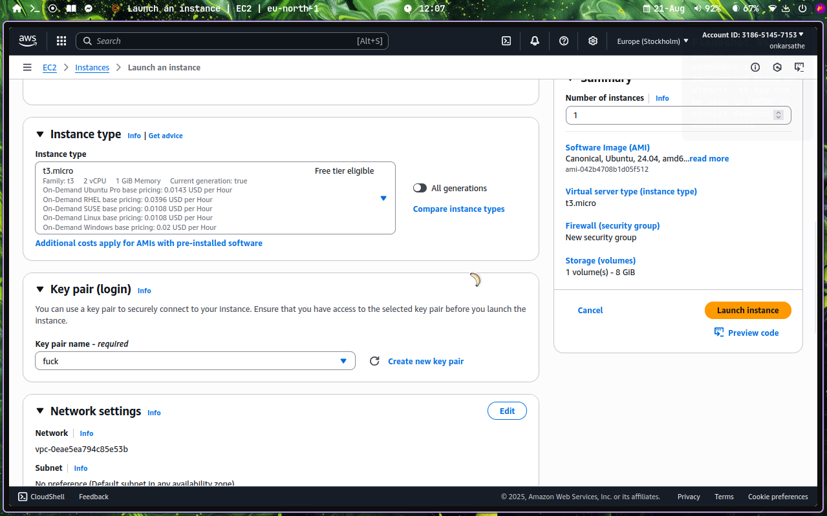
Instance Configuration:
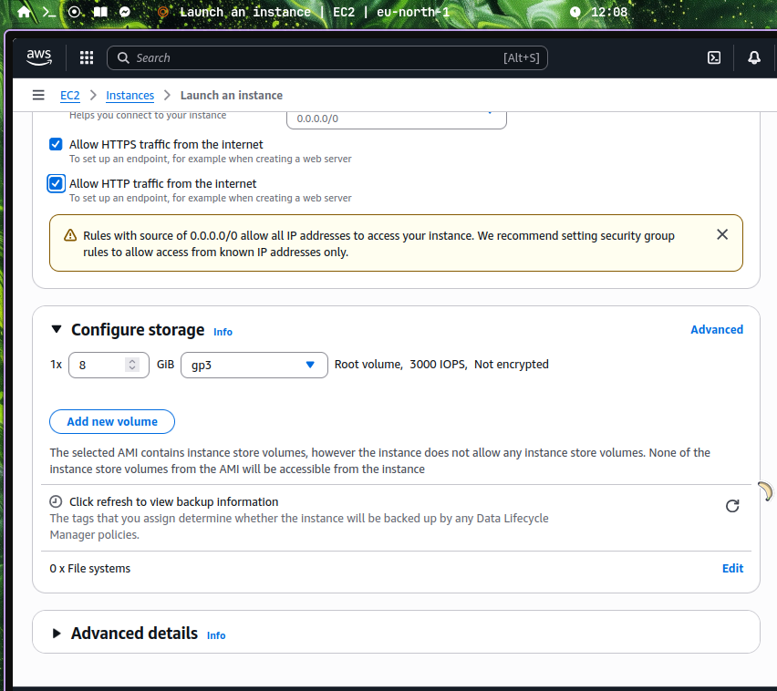
Ssh

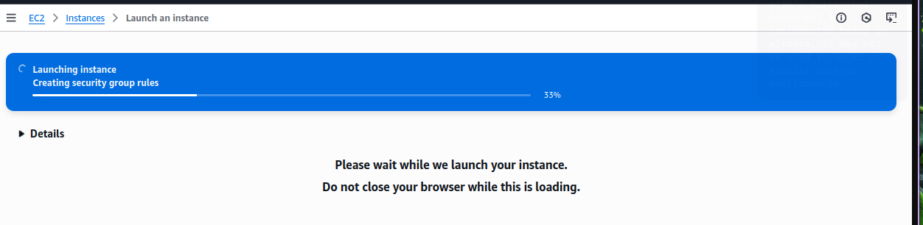
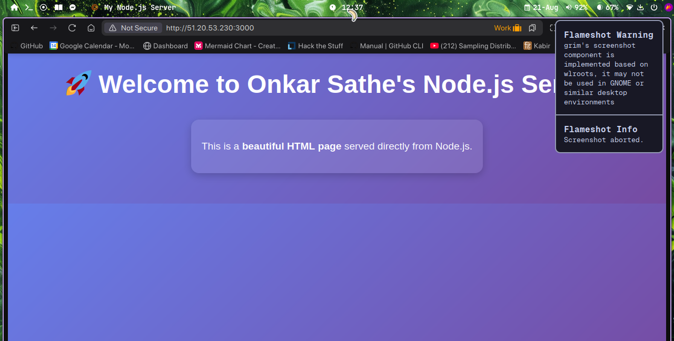
Conclusion:
Through this assignment, we learned how to host a static website using AWS S3. We understood how to create an S3 bucket, upload website files, enable public access, and access the website using a URL. This assignment helped us understand the basics of cloud storage and how AWS makes website deployment simple and efficient.

